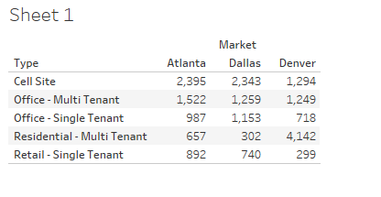

Denver: Sum of ALL sites = 9511

Atlanta: Sum of ALL sites = 10120

Dallas: Sum of ALL sites = 8924

Denver: 7702 total sites in top sites

Atlanta: 6453 total sites in top sites

Dallas: 5797 total sites in top sites

* **Denver:**
  + **Cell Site:** 1294 / 9511 = 13.60 %
  + **Office – Multi-Tenant:** 1249 / 9511 = 13.13 %
  + **Office – Single-Tenant:** 718 / 9511 = 7.55 %
  + **Residential – Multi Tenant:** 4142 / 9511 = 43.55 %
  + **Retail – Single Tenant:** 299 / 9511 = 3.14 %
    - **Top 5** = 80.97 % (Other = 19.03 %)
* **Atlanta:**
  + **Cell Site:** 2395 / 10120 = 23.67 %
  + **Office – Multi-Tenant:** 1522 / 10120 = 15.04 %
  + **Office – Single-Tenant:** 987 / 10120 = 9.75 %
  + **Residential – Multi Tenant:** 657 / 10120 = 6.49 %
  + **Retail – Single Tenant:** 892 / 10120 = 8.81 %
    - **Top 5** = 63.76 % (Other = 36.24 %)
* **Dallas:**
  + **Cell Site:** 2343 / 8924 = 26.25 %
  + **Office – Multi-Tenant:** 1259 / 8924 = 14.11 %
  + **Office – Single-Tenant:** 1153 / 8924 = 12.92 %
  + **Residential – Multi Tenant:** 302 / 8924 = 3.38 %
  + **Retail – Single Tenant:** 740 / 8924 = 8.29 %
    - **Top 5 =** 64.95 %(Other = 35.05 %)

